Computer Networks

Name: Rithvik Rajesh Matta
SRN: PES2UG23CS485
Section: H

Topic:
NS2 Congestion Window

Packet Drop
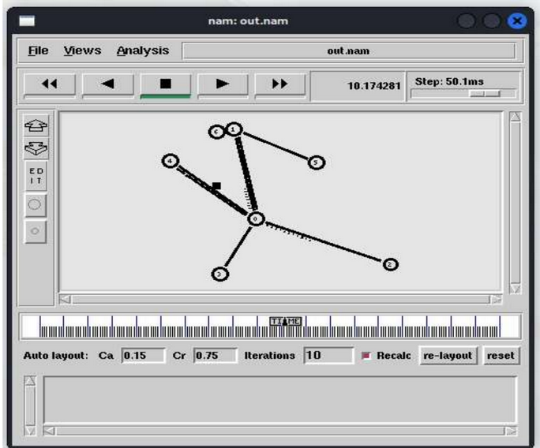
XGraph
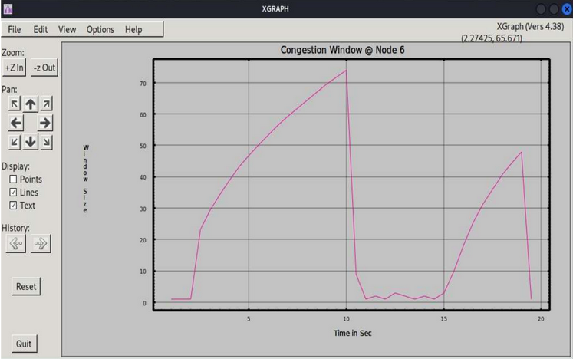
Explanation:
X-axis (Time in Sec): Represents the passage of time in seconds.
Y-axis (Window Size): Represents the size of the congestion window (CWND), indicating how many packets the TCP sender can transmit before waiting for an acknowledgment.

Slow Start (0 - 10 seconds):
Initially, the congestion window size increases exponentially. This phase represents TCP’s slow start, where the window size grows quickly as the sender aggressively tries to increase throughput.

Congestion Event (~10 seconds):
At around 10 seconds, the congestion window size drops sharply. This sudden decrease typically indicates packet loss or network congestion.

Congestion Avoidance & Recovery (10 - 20 seconds):
After the drop, the CWND fluctuates at a lower value, slowly increasing again. This phase represents TCP’s congestion avoidance mechanism, where the sender cautiously increases the window size in a linear fashion to prevent further congestion.

Another Congestion Event (~20 seconds):
At around 20 seconds, another sharp drop in the congestion window occurs, suggesting a second instance of congestion or packet loss.

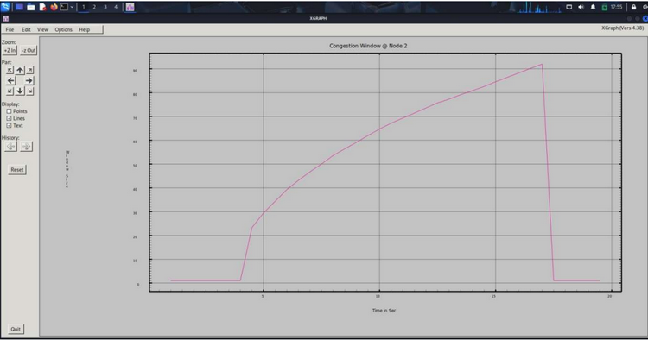

Explanation:
X-axis (Time in Sec): Represents time in seconds.
Y-axis (Window Size): Represents the size of the TCP congestion window, dictating how many packets can be sent before waiting for acknowledgment.

Slow Start (0 - ~3 seconds):
During this phase, the congestion window remains small initially, then starts to increase exponentially. This indicates TCP’s rapid growth in the window size as part of the slow start phase.

Congestion Avoidance (~3 - 15 seconds):
Here, the window size grows more gradually, reflecting a linear increase as TCP transitions into congestion avoidance mode to control network congestion.

Sudden Drop (~15 seconds):
At around 15 seconds, the congestion window experiences a sharp drop from its peak, suggesting a packet loss event caused by congestion or a timeout.

Stabilization (~15 - 20 seconds):
After the drop, the CWND remains at a low value for a while. This indicates that TCP is waiting for retransmissions, and the window size starts to increase again slowly.

TCL File
